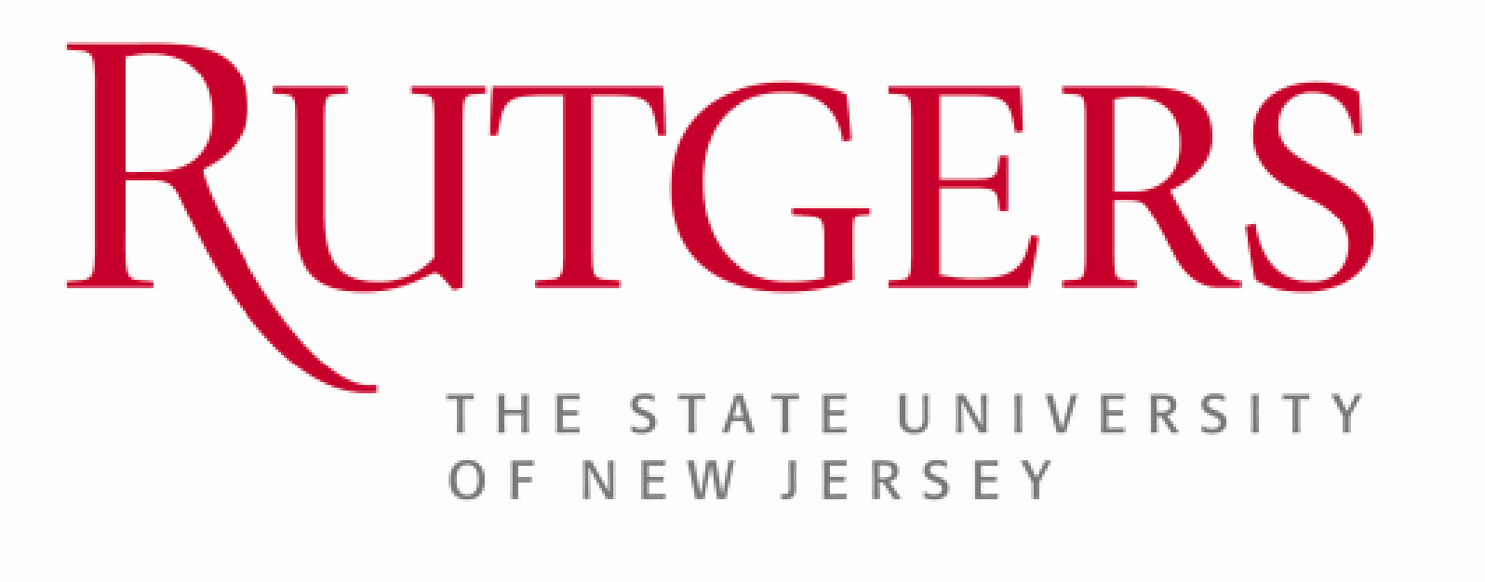

University Senate
Research and Graduate & Professional Education Committee Members (RGPEC)
Response to Charge S-2331: Research Trainee Compensation and Benefits Inequity

- Charge
Charge Number | S-2331
Title | Research Trainee Compensation and Benefits Inequity
Description | Investigate current practices in postdoc and current doctoral student remuneration, in particular as it relates to inequality following fellowship funding and to develop solutions to reward talent.

- Background
Postdoctoral research fellows provide a driving force for research innovation and are essential for the success of Rutgers’ research enterprise. Postdocs are typically paid through their mentors’ research grants according to postdoctoral minimum salary rates as published by the Rutgers Office of University Labor Relations (minimum yearly compensation as of July 1, 2025: $63,968 for new postdocs). However, highly successful postdocs acquire their own independent NIH funding (T32, F32, K99 grants) and must pay themselves through their grants. However, in these cases they are allowed to pay themselves only the NIH rate (as of July 1, 2025: $62,232), which is considerably less than the Rutgers minimum rate. While PIs can theoretically increase postdoctoral salaries through their own fund, it is not allowed to increase the salary of federally funded postdocs with additional federal grant dollars (e.g. from a federal grant of the PI). In addition the Rutgers minimum compensation rates for postdocs are lower compared to comparable peer institutions within the same geographical area (July 1, 2025 minimum rate at Penn: $67,000).

- Discussion
In response to charge S-2331 the Research, and Graduate and Professional Education Committee (RGPEC) investigated current practices in postdoc and current doctoral student remuneration. The committee identified the following areas of concern:
- The best postdocs, i.e. those who are successful in getting their own federal grants, receive less compensation than their PI-supported peers. This situation de-incentives postdocs to seek their own independent grant funding.
- Human Resources generally does not allow principal investigators to pay postdocs more than the minimum rate. There is no system in place to reward highly productive postdocs.
- Rutgers postdoc salaries are not compatible with those from neighboring peer institutions.
In light of these findings, the committee recognizes that Rutgers is not well positioned to recruit and retain the best of the postdocs within a highly competitive market.

- Resolution
Be it resolved:

Given the need to improve Rutgers’ competitiveness to recruit and retain highly qualified postdocs, the University Senate recommends:

- Create a formal system using non-federal funds to supplement compensation for postdocs who manage to obtain their own federal grants/fellowships. This needs to include supplemental salaries provided by the University or other sources.

- Develop a system for all postdocs focused on merit-based pay increases. Performance-based pay increases will allow recruitment and retention of talent.

- Consider modification of minimum pay rates for self-funded postdoctoral researchers and fellows within Rutgers to be better aligned with peer institutions and cost of living in New Jersey.

Member Action:
Approve of the Response to Charge S-2331 as discussed during full RGPEC meeting 02/20/26:
[Quorem met]
Jean Anderson Eloy
Robert Apel
Detlev Boison
Nyla Boswell
Enrique Curchitser
Mert Gurbuzbalaban
Arash Hatefi
Zhengyu Mao
Monica Mazurek
David Salas-de la Cruz
Paul Takhistov
Do not approve of Response:
none
Abstain from Action:
none

