what was the effect of major technological evolutions (e.g. plow, electricity, computers, internet) on income
Major technological revolutions have generally produced large increases in income and living standards, but the gains often arrived slowly and were unevenly distributed at first.

1. The Plow (roughly 3000–1000 BCE)
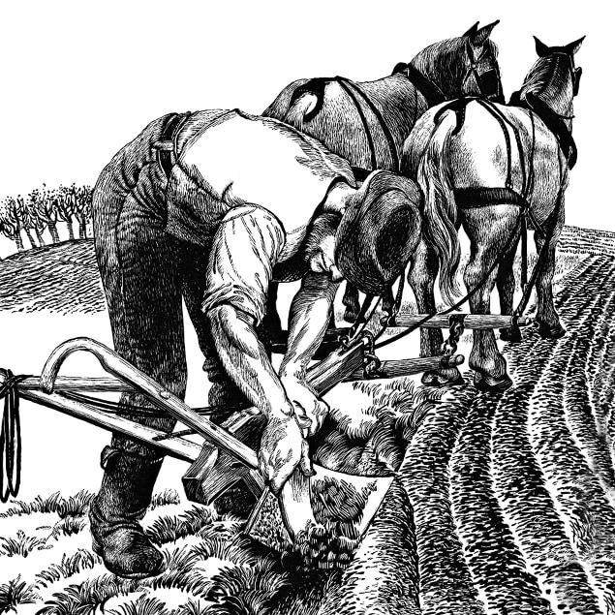


4
Effect on income:
- Increased agricultural productivity dramatically compared with hand tools.
- Allowed a smaller share of the population to produce food for everyone else.
- Supported cities, trade, governments, and specialization.
- Per-capita incomes rose modestly, but for much of preindustrial history gains were absorbed by population growth ("Malthusian trap").
Magnitude:
- Enormous for civilization itself, but difficult to quantify because reliable economic data do not exist.

2. The Industrial Revolution (steam power, mechanization)
Late 1700s–1800s
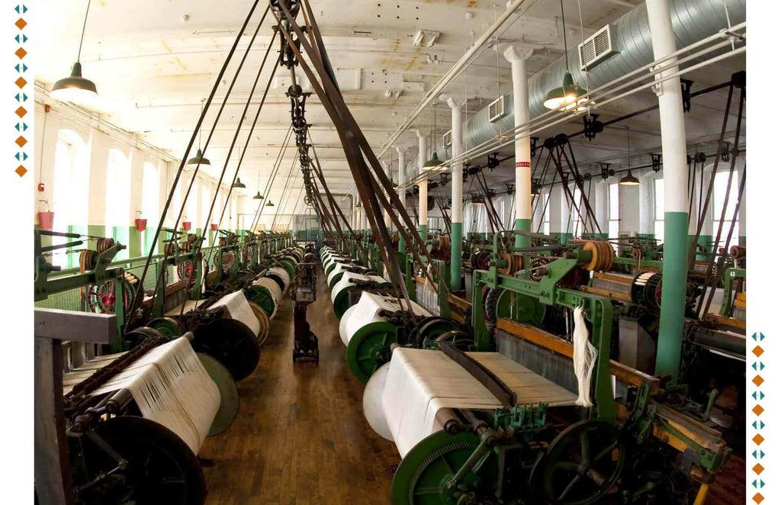


4
Effect on income:
- One of the largest economic transformations in history.
- Productivity in manufacturing soared.
- Real incomes in countries such as the UK and later the US began sustained growth.
Magnitude:
- Before the Industrial Revolution, average incomes changed little over centuries.
- Between 1820 and today, real GDP per capita in leading economies increased roughly 15–30 times.
Many economic historians consider this the single most important turning point in human prosperity.

3. Electricity
Late 1800s–early 1900s
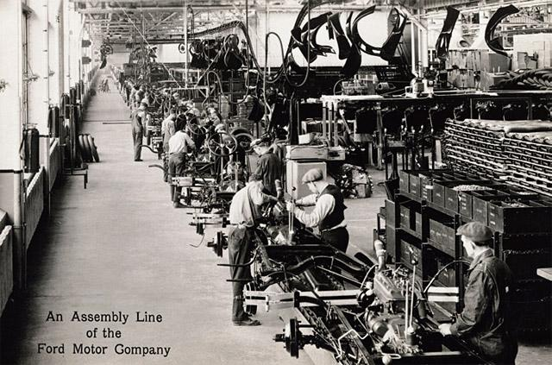

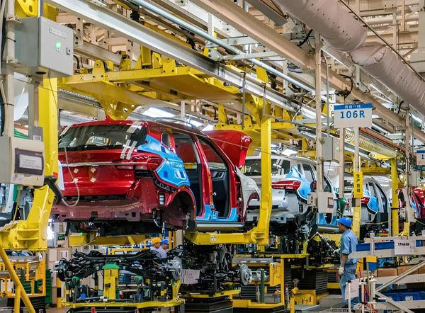
4
Effect on income:
- Factories could be redesigned around electric motors rather than centralized steam engines.
- Extended productive hours.
- Enabled new industries: appliances, telecommunications, refrigeration, modern transportation.
Magnitude:
- Productivity gains were substantial but appeared gradually.
- Studies suggest electricity accounted for a significant portion of U.S. productivity growth from about 1910–1950.
Economists often compare today's AI wave to the electricity revolution because both are "general-purpose technologies."

4. Computers
1950s onward
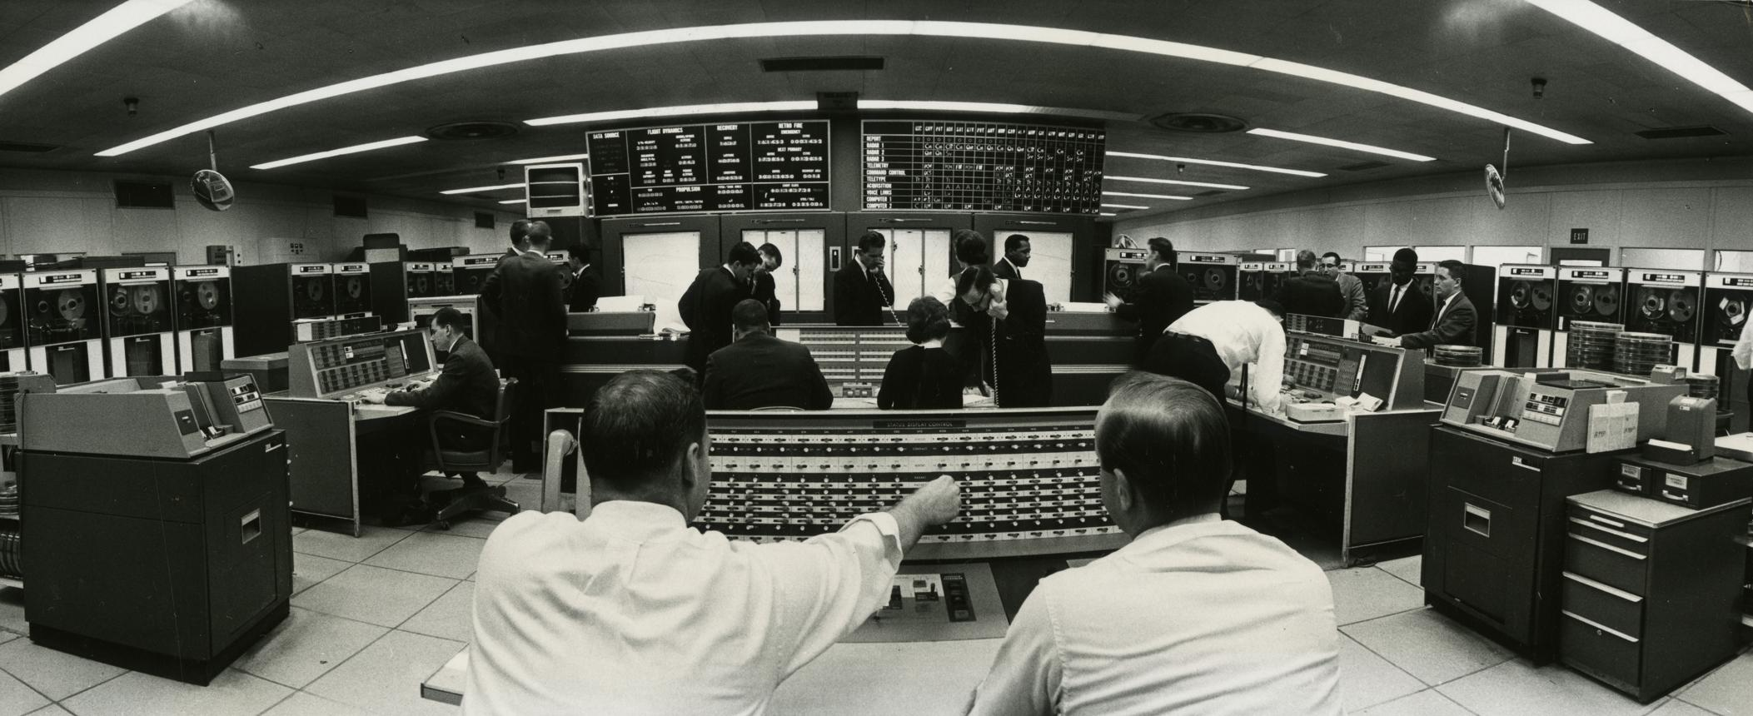


4
Effect on income:
- Automation of calculations, recordkeeping, design, logistics, and finance.
- Large gains in white-collar productivity.
- Created entirely new industries.
Magnitude:
- The U.S. productivity acceleration of the late 1990s is widely attributed to computerization and software.
- GDP per capita continued to rise strongly, though gains were concentrated among highly skilled workers and technology owners.

5. The Internet
1990s onward
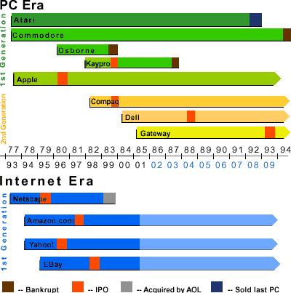
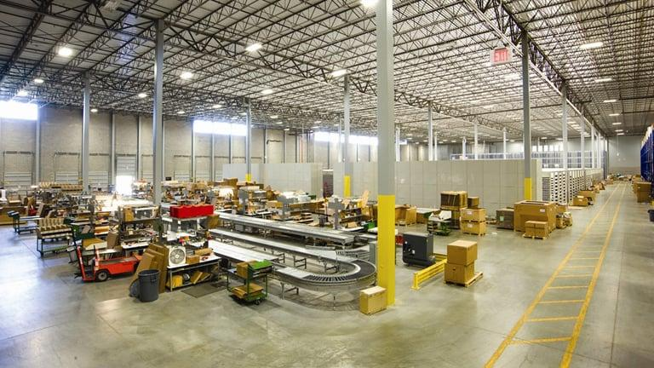

4
Effect on income:
- Reduced information and transaction costs.
- Enabled e-commerce, cloud computing, remote work, digital advertising, online education, and platform businesses.
- Created global markets for knowledge workers.
Magnitude:
- Added trillions of dollars of economic value.
- Generated some of the largest fortunes in history.
- Increased consumer welfare beyond what GDP statistics fully capture.

Comparing the Impact
A rough ranking by long-run effect on human income:
- Industrial Revolution (steam/mechanization) — largest sustained jump.
- Agricultural revolution/plow — foundation for civilization.
- Electricity — transformed nearly every industry.
- Computers — major productivity gains, especially for knowledge work.
- Internet — huge gains through connectivity and market expansion.

Where Might AI Fit?
Many economists believe AI could eventually rank alongside:
- the Industrial Revolution,
- electricity,
- and computers
as a general-purpose technology.
Forecasts vary widely, but some studies estimate AI could raise global GDP by 5–15% or more over the next decade or two, while more optimistic projections envision impacts comparable to earlier industrial transformations.
A key lesson from past revolutions is that the biggest income gains often arrive 10–40 years after the invention, once businesses reorganize around the new technology rather than merely adopting it. Electricity, computers, and the internet all followed that pattern.
put some numbers in average per capita income
A useful way to think about technological revolutions is to compare approximate real GDP per capita (inflation-adjusted, in today's dollars). Historical estimates vary, but the broad picture is remarkably consistent.
Era / Technology | Approximate Real GDP per Capita (2025 USD) | Multiple of Prior Era
Pre-plow hunter-gatherers (before ~10,000 BCE) | $1,000–$2,000 | —
Early agricultural societies (plow era) | $1,500–$3,000 | ~1–2×
Roman Empire (~1 CE) | $2,000–$4,000 | modest increase
Europe before Industrial Revolution (~1700) | $3,000–$5,000 | little change over centuries
Industrial Revolution underway (~1870 UK/US) | $6,000–$10,000 | ~2×
Electricity era (~1950 US) | $15,000–$20,000 | ~2×
Computer era (~1990 US) | $35,000–$45,000 | ~2×
Internet era (~2025 US) | $70,000–$90,000 | ~2×

The striking pattern
For most of human history—from the invention of agriculture until about 1800—average income stayed roughly between $2,000 and $5,000 per person per year (in today's purchasing power).
Then:
- Industrial Revolution: ~$4,000 → ~$8,000–10,000
- Electricity & mass production: ~$8,000 → ~$20,000
- Computers: ~$20,000 → ~$40,000
- Internet & digital economy: ~$40,000 → ~$80,000
In the United States specifically:
Year | Approximate Real GDP per Capita
1820 | ~$3,000
1870 | ~$6,000
1913 | ~$12,000
1950 | ~$18,000
1973 | ~$28,000
1995 | ~$42,000
2025 | ~$80,000+

What this means
The plow and agriculture may have been the most important inventions for creating civilization, but they did not create large sustained increases in average income because population growth absorbed much of the gain.
The technologies that produced the largest measured increases in per-capita income were:
- Industrialization (steam power and mechanization): roughly +100% to +200%.
- Electricity and mass production: roughly +100%.
- Computers and software: roughly +100%.
- Internet and digital networks: roughly +50–100% so far.
Economists often note that a typical American today enjoys a real income about 20–25 times higher than a typical American in 1820 and perhaps 40–50 times higher than the average person living in the ancient world. Much of that increase can be traced to a sequence of general-purpose technologies: mechanization, electricity, computing, and networking.
adjust for cost of living
I’ll treat “cost of living” as purchasing-power adjusted income—what income could actually buy—rather than just nominal dollars. The hard part is ancient/preindustrial comparisons, so I’ll use broad ranges rather than false precision.
Thought for 4s
Yes — the earlier numbers were already inflation-adjusted, but here is a cleaner cost-of-living / purchasing-power adjusted version.
These are approximate real GDP per person, adjusted for inflation and purchasing power, mostly in 2011 international dollars. That means they try to measure what people could actually buy.
Period / technology | World or U.S. real income per person | Meaning
Ancient agrarian world / plow era | ~$1,000–$2,000 | Bare subsistence for most people
Roman Empire / classical era | ~$1,500–$3,000 | Modest surplus, but still poor by modern standards
Western Europe around 1700 | ~$2,000–$4,000 | Little change over centuries
U.S. around 1820 | ~$2,500–$3,500 | Early industrial takeoff
U.S. around 1870 | ~$5,000–$7,000 | Railroads, steam, factories
U.S. around 1913 | ~$8,000–$12,000 | Electricity spreading
U.S. around 1950 | ~$15,000–$20,000 | Electricity, cars, mass production
U.S. around 1995 | ~$35,000–$45,000 | Computers/software
U.S. today | ~$70,000+ | Internet, digital economy, advanced services
The big picture: after adjusting for cost of living, most humans lived around $1,000–$4,000 per person for thousands of years. Then modern technology lifted U.S. real income per person roughly 20-fold from 1820 to the late 20th century.
So the adjusted story is:
Plow/agriculture: civilization, but not big sustained income gains.
Industrial Revolution: income roughly doubled or tripled.
Electricity/mass production: another large doubling.
Computers/internet: roughly another doubling since the late 20th century.
https://chatgpt.com/s/t_6a256ad175a88191b1c5920779245e68

has the time lag of the benefits shortened?
Yes. Most economic historians believe the lag between invention and broad income gains has generally shortened, although not uniformly.
Technology | Approximate invention | Major economic impact begins | Lag
Plow | ~3000 BCE | Spread over centuries | Hundreds of years
Steam engine | 1760s–1780s | Early-mid 1800s | 30–70 years
Electricity | 1880s | 1910s–1930s | 20–50 years
Automobile | 1890s | 1920s–1950s | 20–40 years
Computer | 1950s–1960s | 1980s–1990s | 20–40 years
Internet | 1990s | Late 1990s–2010s | 5–20 years
Smartphones | 2007 | 2010s | 3–10 years
Generative AI | 2022 | Still unfolding | TBD
The reason is that society has become much better at:
- spreading knowledge,
- raising capital,
- building infrastructure,
- training workers,
- scaling businesses globally.
For example, it took decades before factories were reorganized around electricity. Simply replacing a steam engine with an electric motor produced modest gains. The big gains came when factories were redesigned around assembly lines and distributed power.
Similarly, computers were invented in the 1940s and 1950s, but the famous "productivity boom" didn't show up until the late 1990s, when businesses reorganized around networks, databases, and enterprise software.
The internet's benefits appeared faster because:
- telecommunications infrastructure already existed,
- computers were widespread,
- global markets were connected,
- software could scale instantly.
An interesting exception is that while adoption is getting faster, economy-wide productivity gains are not always appearing faster. Economists sometimes distinguish between:
- Technology diffusion (fast), and
- Organizational transformation (still slow).
For example:
- ChatGPT reached 100 million users in months.
- It may still take 5–15 years for companies, schools, governments, and professions to fully reorganize around AI.
Many economists compare AI today not to a new app, but to electricity. If that analogy is right, the biggest income gains may come not from the AI models themselves, but from the redesign of work, firms, and industries that follows.
A useful rule of thumb is:
- Pre-industrial innovations: centuries
- Industrial-era innovations: 30–50 years
- Digital-era innovations: 5–20 years
- AI: likely 5–15 years for noticeable effects, but perhaps 20+ years for the full economic impact.
what can a state do to deal with the unemployment and readjustment effect?
Historically, the countries that benefited most from major technological shifts were not those that tried to stop the technology, but those that helped workers transition quickly into new jobs.
A state has several tools:

1. Education and Retraining
The most effective long-term response.
Examples:
- Subsidized community colleges
- Technical and vocational training
- Mid-career retraining programs
- Apprenticeships with employers
During the Industrial Revolution, workers moved from farms to factories. During the computer revolution, workers moved from clerical work into service and knowledge jobs.

2. Wage Insurance
Instead of only paying unemployment benefits, governments can temporarily compensate workers who take a lower-paying job.
Example:
- Worker earns $80,000.
- New job pays $60,000.
- Government pays part of the $20,000 difference for a few years.
This encourages rapid re-employment.

3. Mobility Assistance
Many new jobs arise in different locations.
Programs can help with:
- Relocation expenses
- Housing support
- Transportation
- Remote-work infrastructure

4. Strong Safety Nets
Temporary support while people retrain:
- Unemployment insurance
- Health insurance continuity
- Childcare assistance
The goal is to reduce hardship without discouraging work.

5. Encourage New Business Formation
Most new jobs come from new firms rather than established firms.
Policies include:
- Easier business formation
- Access to capital
- Reduced regulatory barriers
- Support for entrepreneurship
Historically, technological revolutions destroy some occupations but create entirely new industries.

6. Public Infrastructure Investment
Governments can create employment while increasing productivity:
- Transportation
- Energy grids
- Broadband
- Water systems
The U.S. interstate highway system is a classic example.

7. Tax the Gains, Not Necessarily the Technology
Many economists prefer:
- Allow innovation to proceed.
- Tax part of the increased profits, capital gains, or high incomes generated.
- Use the revenue to fund transition assistance.
This is generally viewed as less harmful than trying to slow innovation itself.

8. Lifelong Learning Accounts
A newer idea.
Workers accumulate training credits throughout their careers that can be used whenever technology changes their occupation.

What Has Worked Best Historically?
Countries such as Denmark and Singapore have often emphasized a model sometimes called "flexicurity":
- Firms can adopt new technology and adjust employment.
- Workers receive strong support for retraining and finding new jobs.
- The labor market remains flexible.
- Invest on education
- Invest on career change management
This tends to produce better outcomes than either:
- blocking technology, or
- providing support without helping people return to work.

What if AI causes much larger displacement?
If AI proves substantially more disruptive than previous technologies, economists discuss additional options:
- Universal basic income (UBI)
- Negative income taxes
- Reduced work weeks
- Public employment programs
- Broader employee ownership of capital and AI-driven firms
These remain largely experimental.
The historical lesson from the plow, steam power, electricity, computers, and the internet is that the biggest challenge is usually not permanent unemployment but the transition period. The most successful societies have been those that shortened that transition through education, mobility, and income support while allowing productivity growth to continue.
Are US states not countries? Can the state of NJ deal with its AI evolution problems?
That's a good distinction. A U.S. state like New Jersey cannot control monetary policy, immigration policy, Social Security, or most labor-market regulations. But it can still do quite a lot.
For New Jersey, I would focus on six areas:

1. Make Rutgers the AI retraining hub
New Jersey's biggest advantage is probably Rutgers University.
The state could:
- Provide free or heavily subsidized AI certificates.
- Create "AI for Accountants," "AI for Nurses," "AI for Teachers," and "AI for Government Workers" programs.
- Offer rapid 6–12 week credential programs.
The goal is not to create AI engineers; it is to create AI-enabled workers.

2. Create AI Transition Accounts
For workers displaced by AI:
- $5,000–$15,000 retraining vouchers.
- Usable at Rutgers, community colleges, or approved providers.
- Target occupations at highest risk of automation.
This is probably more effective than extending unemployment benefits alone.

3. Use Tax Incentives to Keep Jobs in NJ
Offer incentives to firms that:
- Deploy AI,
- Increase productivity,
- And retain or retrain existing workers.
You want companies to say:
"We'll retrain 100 claims processors into AI supervisors"
rather than simply eliminating 100 positions.

4. Modernize State Government First
New Jersey itself is one of the state's largest employers.
The state could:
- Deploy AI in permitting,
- DMV services,
- benefit administration,
- procurement,
- tax administration.
Historically, governments that adopt technology early learn how to regulate and support it better.

5. Build an AI Corridor
New Jersey sits between:
- New York City
- Philadelphia
and has:
- pharmaceuticals,
- financial services,
- logistics,
- healthcare,
- telecommunications.
Rather than competing with Silicon Valley, New Jersey could specialize in:
- AI for healthcare,
- AI for life sciences,
- AI for audit and compliance,
- AI for supply chains.
These align with existing strengths.

6. Expand Community College Workforce Programs
New Jersey's community colleges are often better positioned than universities for rapid workforce adjustment.
Examples:
- AI-assisted bookkeeping
- AI-assisted coding
- AI-assisted healthcare administration
- AI-assisted manufacturing
The workers most affected by AI are often not university graduates but middle-skill workers.

For New Jersey Specifically
The occupations likely to see the most disruption include:
- Customer service
- Claims processing
- Back-office financial operations
- Basic bookkeeping
- Administrative support
- Routine legal and compliance work
Ironically, New Jersey's large concentration of:
- healthcare,
- pharma,
- finance,
- education,
means it may also be one of the states that benefits most from AI if it adapts quickly.

If I were advising the governor of New Jersey, my top three priorities would be:
- A statewide Rutgers/community-college AI retraining initiative.
- AI transition vouchers for displaced workers.
- An AI innovation cluster focused on healthcare, pharmaceuticals, and financial compliance.
- Invest on educational modules for AI transition and also market these to other localities
Those are areas where a state government can act directly without waiting for Washington, and they build on strengths New Jersey already possesses rather than trying to become another Silicon Valley.

